Chapter 4
RESULTS AND DISCUSSIONS
This chapter analyzes the data collected from the experiments. The results are supported by relevant tables, figures, and statistical analysis.
4.1 Temperature and Humidity Sensor Accuracy Test
In experiment 3.2.1, the DHT22 temperature and humidity sensor was performed by comparing its measured values against a calibrated digital thermometer and hygrometer used as the reference instrument. A series of repeated trials were conducted under indoor environmental conditions to minimize external thermal disturbances.
The reliability of the environmental monitoring system was evaluated through a series of calibration tests focusing on temperature and relative humidity. By comparing sensor outputs against high-precision reference instruments, the system’s performance was quantified using four primary metrics: Mean Absolute Error (MAE), Mean Percent Error (MPE), Overall Accuracy (A), and Consistency (CV).
The linear curve was made by analyzing these data through the concept of linear regression [..] to show their relationship by scattering the data to get the linear equation. The linear curve is shown in Fig. 4.1. for temperature and Fig 4.2 for humidity. With this, the temperature and humidity equation is given by;
$T_{DHT22}= (0.7457×T_{ref})+ 6.339$ (4.1)

where:
$T_{DHT22}$= Temperature values, and
$T_{ref}$ = reference temperature.
$H_{DHT22}= (0.772×H_{ref})+ 12.4195$ (4.2)
$H_{DHT22}$ = humidity values, and
$H_{ref}$ = hygrometer reading.
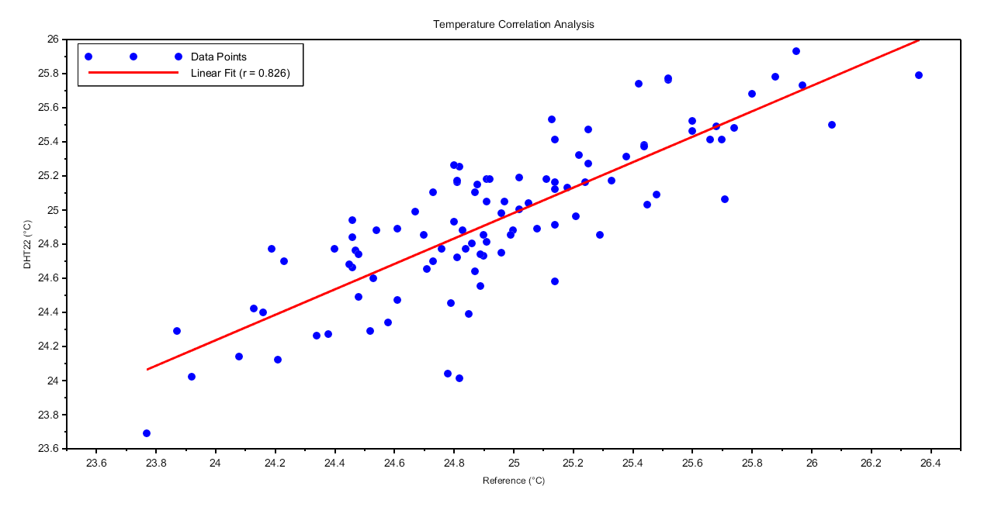

Figure 4.1: DHT22 (Temperature) Linear curve

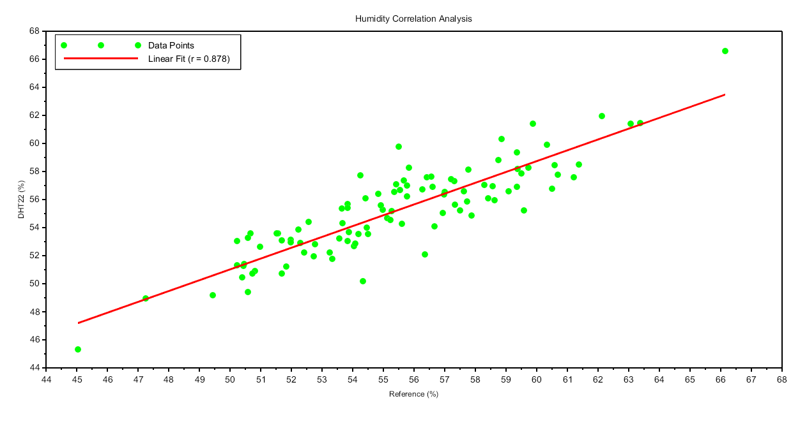

Figure 4.2: DHT22 (Humidity) Linear curve
This linear curve has a correlation of 0.826 and 0.878 which indicates a very strong linear relationship. This proves that as environment changes, DHT22 tracks the reference tool accurately
Table 4.1: Summary Calibration Accuracy Metrics in Temperature
Test | Results
Mean Absolute Error (MAE) | 0.23°C
Mean Percent Error (MPE) | 0.91%
Overall Accuracy (A) | 99.09%
Consistency | 0.9818

Table 4.2: Summary Calibration Accuracy Metrics in Humidity
Test | Results
Mean Absolute Error (MAE) | 1.42%
Mean Percent Error (MPE) | 2.54%
Overall Accuracy (A) | 97.46%
Consistency | 0.9411
DHT22 demonstrated a very high level of precision in temperature measurement. With a Mean Absolute Error (MAE) of only 0.23°C and overall accuracy of 99.09%, for the humidity the DHT22 sensor performed well with an accuracy of 97.46%. Although the error is higher than the temperature (MAE of 1.42% RH), this is well within the manufacturer's expected tolerance for DHT22 sensors. The sensor is highly reliable for temperature monitoring within the tested (23°C -- 26°C), and the sensor effectively captured the fluctuations in environmental humidity.
4.2 Motion Sensor Accuracy Test
The experiment was conducted to evaluate the performance of the motion sensor under varying distances and angular positions. For each distance-angle configuration, two conditions were tested: with motion and without motion.
The results of the experiment indicate that the motion sensor maintained a consistently high level of detection performance across the tested distances and angles. As shown in Table 4.3, the highest detection rate recorded was 99% at 3 meters and an angle of 15°, demonstrating optimal sensor responsiveness under this configuration. In contrast, the lowest detection rate observed was 82% at distance of 4 meters and an angle of 45°, which suggests a reduction in detection capability as both distance and angular deviation increase. Despite this decrease at the farthest and widest configuration, the overall performance of the sensor remained strong, with detection rates consistently above 80% across all tested ranges. These findings confirm that the sensor operates reliably within the evaluated parameters while showing expected sensitivity variations at extended distances and wider angles.
Distance (m) | Angle (°) | Total Trials | TP | FN | TN | FP | Accuracy | Sensitivity | Specificity
1 meter | 0 | 100 | 87 | 13 | 100 | 0 | 93.5% | 87% | 100%
1 meter | 15 | 100 | 92 | 8 | 100 | 0 | 96% | 92% | 100%
1 meter | 30 | 100 | 93 | 7 | 100 | 0 | 96.5% | 93% | 100%
1 meter | 45 | 100 | 85 | 15 | 100 | 0 | 92.5% | 85% | 100%
Table 4.3: Motion Performance at 1-meter Distance

Distance (m) | Angle (°) | Total Trials | TP | FN | TN | FP | Accuracy | Sensitivity | Specificity
2 meters | 0 | 100 | 91 | 9 | 100 | 0 | 95.5% | 91% | 100%
2 meters | 15 | 100 | 92 | 8 | 100 | 0 | 96% | 92% | 100%
2 meters | 30 | 100 | 91 | 9 | 100 | 0 | 95.5% | 91% | 100%
2 meters | 45 | 100 | 89 | 11 | 100 | 0 | 94.5% | 89% | 100%
Table 4.4: Motion Performance at 2-meter Distance

Distance (m) | Angle (°) | Total Trials | TP | FN | TN | FP | Accuracy | Sensitivity | Specificity
3 meters | 0 | 100 | 94 | 6 | 100 | 0 | 97% | 94% | 100%
3 meters | 15 | 100 | 99 | 1 | 100 | 0 | 99.5% | 99% | 100%
3 meters | 30 | 100 | 89 | 11 | 100 | 0 | 94.5% | 89% | 100%
3 meters | 45 | 100 | 94 | 6 | 100 | 0 | 97% | 94% | 100%
Table 4.5: Motion Performance at 3-meter Distance

Table 4.6: Motion Performance at 4-meter Distance
Distance (m) | Angle (°) | Total Trials | TP | FN | TN | FP | Accuracy | Sensitivity | Specificity
4 meters | 0 | 100 | 88 | 12 | 100 | 0 | 94% | 88% | 100%
4 meters | 15 | 100 | 91 | 9 | 100 | 0 | 95.5% | 91% | 100%
4 meters | 30 | 100 | 84 | 16 | 100 | 0 | 92% | 84% | 100%
4 meters | 45 | 100 | 82 | 18 | 100 | 0 | 91% | 82% | 100%

4.3 Wireless Sensor Nodes Transmission Test
The experiment was performed by installing the sensor nodes at fixed positions inside a 5 m x 7 m air-conditioned room and monitoring both the transmitted and received data using separate laptops. Each transmission trial consisted of one complete data packet containing the Node ID, PIR voltage output, temperature, and humidity. A total of 100 consecutive packets were transmitted.
As shown in Table 4.7, all 100 transmitted packets were successfully received by the control hub, with zero failed transmissions recorded. This corresponds to a 100% transmission success rate. No packets were missing, incomplete, corrupted, or mismatched during the entire testing period. The consistent packet status shows that the communication link ensured accurate data transmission and stable synchronization between the sensor node and the control hub during the experiment.
Table 4.7: Transmission Performance of Sensor Nodes
Sensor Node ID | Data Packet (Transmitted) | Data Packet (Received) | Failed Transmissions | TSR (%)
Sensor Node 1 | 100 | 100 | 0 | 100%
Sensor Node 2 | 100 | 100 | 0 | 100%
Sensor Node 3 | 100 | 100 | 0 | 100%
4.4 AIRWise IR Transmission Accuracy Test

